**COLOR DETECTION WITH PYTHON**

**A PROJECT REPORT**

#### 

#### ***Submitted by***

***MEENALOSHINI.D***

***(Reg. No: 19S018 )***

***of***

**5 Year Integrated M.Sc., (Data Science)**

**in**

**DEPARTMENT OF APPLIED MATHEMATICS AND COMPUTATIONAL SCIENCE**

### **THIAGARAJAR COLLEGE OF ENGINEERING**

**(A Govt. Aided Autonomous Institution**

**affiliated to Anna University)**

**MADURAI – 625015**

|  |  |
| --- | --- |
|  |  |
|  |  |

##### **INTRODUCTION :**

# **What is Color Detection?**

Color detection is the process of detecting the name of any color. Simple isn’t it? Well, for humans this is an extremely easy task but for computers, it is not straightforward. Human eyes and brains work together to translate light into color. Light receptors that are present in our eyes transmit the signal to the brain. Our brain then recognizes the color.In this color detection Python project, we are going to build an application through which you can automatically get the name of the color by clicking on them. So for this, we will have a data file that contains the color name and its values. Then we will calculate the distance from each color and find the shortest one.Colors are made up of 3 primary colors; red, green, and blue. In computers, we define each color value within a range of 0 to 255.The pandas library is very useful when we need to perform various operations on data files like CSV. pd.read_csv() reads the CSV file and loads it into the pandas DataFrame. csv file includes 865 color names along with their RGB and hex values.

**OBJECTIVE OF THE PROJECT:**

To detect the color of the specific spot of the picture is the main aim of the project.also at the end of the project we can come to know about various forms of colors formed from red,green and blue colors.there are 865 colors formed from these three colors.so,here we used python language to implement the project.

using,opencv,numpy and pandas we have made the computer to detect the colors.

**DESCRIPTION OF THE PROJECT:**

Colour detection is the process of detecting the name of any color. Human eyes and brains work together to translate light into color. Light receptors that are present in our eyes transmit the signal to the brain. Our brain then recognizes the color.OpenCv is a Computer Vision library. Computer vision is the science that means to give a comparative, if not better, capacity to a machine or PC. Computer vision is worried about the programmed extraction, investigation and comprehension of valuable data from a single picture or a grouping of pictures. Some of the basic image processing capabilities include filtering, edge detection, corner detection, sampling and interpolation, color conversion, morphological operations, histograms and many more. Color detection using opencv has many advantages like, it allows the detection of a specific color in a livestream video content. In this opencv color detection system there are four major modules, activated webcam, scan object, match frame parts and system results. Users can open webcam by clicking the webcam button. Then the algorithm analysis the pattern of the framed part of webcam. Pattern is matched with defined color pattern by RGB color model. If the pattern matched with the potential pattern of RGB color model then the system results with the correct output.

**Advantages**

* The system is user-friendly and has simple interface.
* Can be used in manufacturing companies.

**IMPLEMENTATION:**

**1. Importing required package and load the image:**

import cv2

import numpy as np

import pandas as pd

img_path = “D://OpenCV//shape-detection//New folder//color palette.jpg”

img = cv2.imread(img_path)

# **2. Next, we read the CSV file with pandas:**

The pandas library is very useful when we need to perform various operations on data files like CSV. pd.read_csv() reads the CSV file and loads it into the pandas DataFrame. We have assigned each column with a name for easy accessing.

index=[“color”,”color_name”,”hex”,”R”,”G”,”B”]

csv = pd.read_csv(‘colors.csv’, names=index, header=None

**3. Set a mouse callback event on a window:**

First, we created a window in which the input image will display. Then, we set a callback function which will be called when a mouse event happens.

cv2.namedWindow(‘color detection’)

cv2.setMouseCallback(‘color detection’,draw_function)

# **4. Create the draw_function:**

It will calculate the rgb values of the pixel which we double click. The function parameters have the event name, (x,y) coordinates of the mouse position, etc. In the function, we check if the event is double-clicked then we calculate and set the r,g,b values along with x,y positions of the mouse.

def draw_function(event, x,y,flags,param):

if event == cv2.EVENT_LBUTTONDBLCLK:

global b,g,r,xpos,ypos, clicked

clicked = True

xpos = x

ypos = y

b,g,r = img[y,x]

b = int(b)

g = int(g)

r = int(r)

# **5. Calculate distance to get color name:**

We have the r,g and b values. Now, we need another function which will return us the color name from RGB values. To get the color name, we calculate a distance(d) which tells us how close we are to color and choose the one having minimum distance.

Our distance is calculated by this formula:

***d = abs(Red — ithRedColor) + (Green — ithGreenColor) + (Blue — ithBlueColor)***

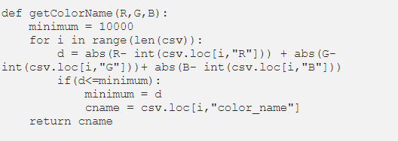

# **6. Display image on the window:**

Whenever a double click event occurs, it will update the color name and RGB values on the window.Using the cv2.imshow() function, we draw the image on the window. When the user double clicks the window, we draw a rectangle and get the color name to draw text on the window using cv2.rectangle and cv2.putText() functions.

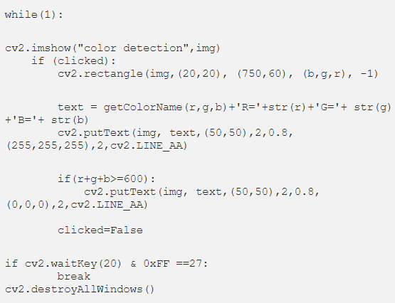

**Full code:**

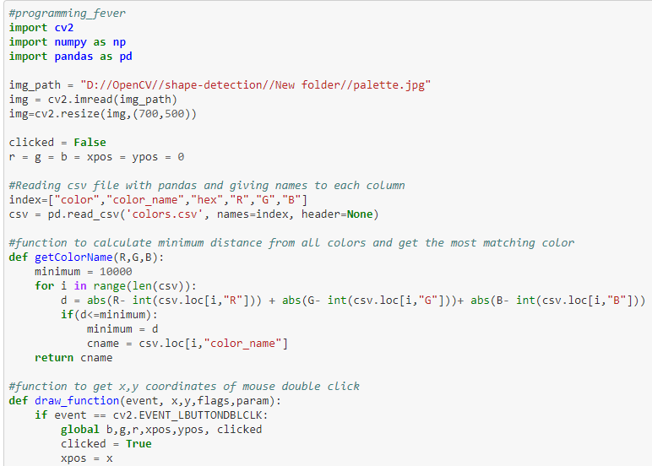

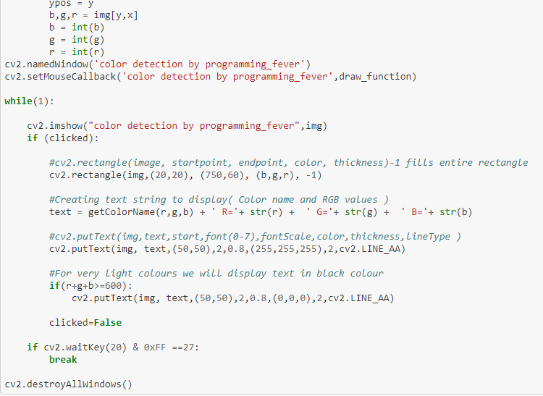

**Output:**

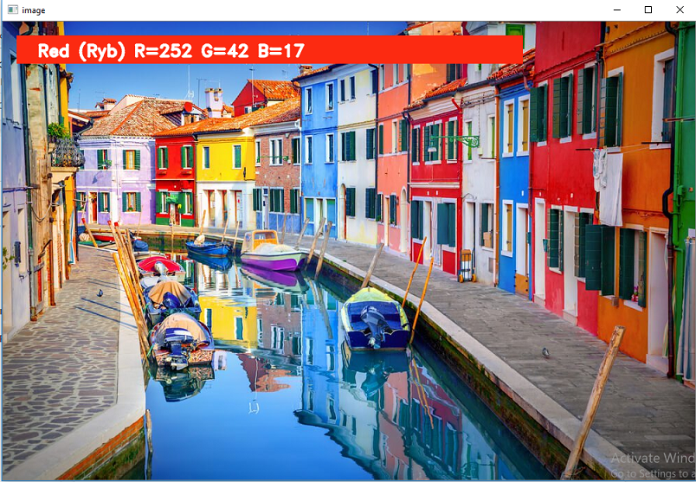

This box is displayed when the user has clicked the red color .also the number combination has beenn displayed.

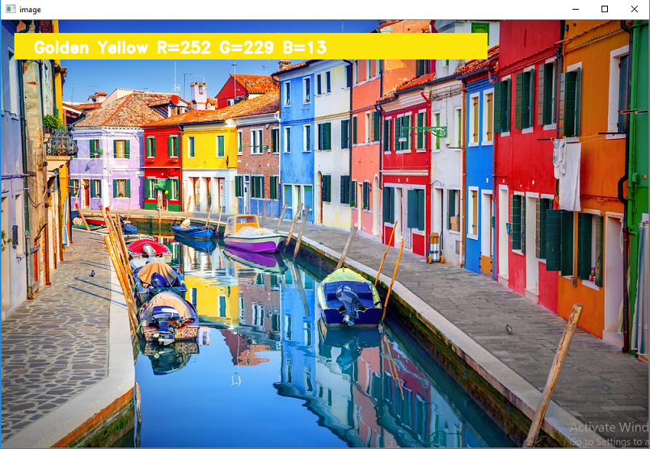

This box is displayed when the user has clicked the yellow color .also the number combination has been displayed.

**SIGNIFICANCE:**

Color detection is necessary to recognize objects, it is also used as a tool in

various image editing and drawing apps.

HEX value is nothing but the conversion of integer into hexa decimal value.

This is an implementation of detecting multiple colors (here, only *red*, *green* and *blue* colors have been considered) in real-time using Python programming language.Mainly used two functions are:

**OPENcv:**

OpenCV is a huge open-source library for computer vision, machine learning, and image processing. OpenCV supports a wide variety of programming languages like Python, C++, Java, etc. It can process images and videos to identify objects, faces, or even the handwriting of a human. When it is integrated with various libraries, such as [Numpy](https://www.geeksforgeeks.org/python-numpy/) which is a highly optimized library for numerical operations, then the number of weapons increases in your Arsenal i.e whatever operations one can do in Numpy can be combined with OpenCV.

**NUMPY:**

Numpy is a general-purpose array-processing package. It provides a

high-performance multidimensional array object, and tools for working with

these arrays. It is the fundamental package for scientific computing with Python.Besides its obvious scientific uses, Numpy can also be used as an efficient multi-dimensional container of generic data.